Lab: Unit 09 – Database Applications

# Overview

In this lab we will explore how to build a database in the Azure cloud and then create a databases application using the Microsoft PowerApps cloud Service.

## Learning Objectives

Upon completion of the lab, you should be able to:

* Create an SQL Server and Database in Azure
* Deploy a SQL server database to the cloud using Azure Data Studio
* Use PowerApps to build a Data-Driven Database Application
* Deploy and run a PowerApp to your Mobile Device

## What you will need

To complete this lab, you will need an Azure and PowerApps accounts. Fortunately all SU students have these accounts already.

* Login to <https://portal.azure.com> using your SU email [***netid*@syr.edu**](mailto:netid@syr.edu)with your SU NetID password.
* Login to <https://make.powerapps.com> using your SU email [***netid*@syr.edu**](mailto:netid@syr.edu)with your SU NetID password.

# Walkthrough

In this walkthrough we will demonstrate how to build a cloud SQL Server database in azure. You will use this to create the PowerApp later in the walkthrough. You can also use the same database for when you create a PowerApp as part of your final project.

## Step 1: Create an Azure SQL Server Database

Before we get started with PowerApps, you must first create a cloud database as the data source of the application. We will create this database on the Microsoft Azure cloud service.

1. Go to <https://portal.azure.com> and login with your [***netid*@syr.edu**](mailto:netid@syr.edu)with your SU NetID Password.
2. From the Azure Portal Screen, Click **Create a Resource**  
   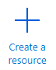
3. In the search box, enter **SQL Database** and press enter.
4. From the SQL Database screen click **Create**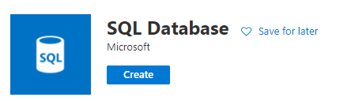
5. You will not see the **Create SQL Database** screen. Enter the information as follows:
   1. Subscription:  **Azure for Students**
   2. Resource Group 🡪 Create new 🡪 IST659
   3. Database name **ist659*yournetid***
   4. Server -> Create new
      1. Server name: **ist659*yournetid***
      2. Server admin login: ***yournetid***
      3. Password: <<create-your-own-password>> **🡨 Write it down!!!!!**
      4. Location: **(US) East US**
   5. Want to use an Elastic Pool? 🡪 **No**
   6. IMPORTANT: Compute + Storage 🡪 Click **Configure Database**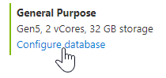
      1. Change the **Compute Tier** from **Provisioned**  to **Serverless**. This will save you a lot of free student credits!  
         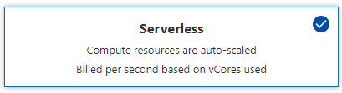
      2. Click **Apply** to save your changes and return to the **Create SQL Database Screen**
   7. **Review all settings**. After you know they are correct, click **Review + Create**  
      
6. Take a break. It can take 10-30 minutes for the server to be setup and the database to be deployed.
7. When your resources are provisioned, they will appear in the **Recent Resources** section on <https://portal.azure.com>   
   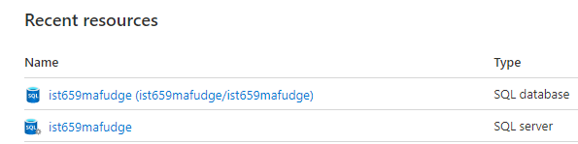
8. We need to configure your SQL server so that other Azure services such as **PowerApps** can access it. Do the following:
   1. Click on the SQL Server **ist659*yournetid***
   2. From the SQL Server Screen click on **Firewalls and Virtual Networks** (Under the **Security** section on the left-hand side)  
      
   3. Find **Allow Azure services and resources to access this server** and select **Yes**  
      This will permit **PowerApps** to access your cloud database.
   4. After you have made this chance, click **Save** at the top.  
      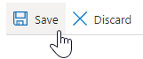

Your Azure database is now ready to use!

## Step 2: Connect to your Azure Database using Azure Data Studio

In this next step, we will demonstrate how to connect to your cloud SQL Server database using Azure Data Studio.

1. Open **Azure Data Studio** on your computer
2. Make sure the **Side Bar** is visible by clicking **Ctrl+B** to turn it on.  
   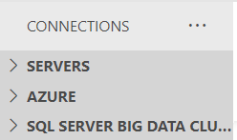
3. Click on the **>** **AZURE** section from the Side Bar, then click **Sign In To Azure**, then click **Add An Account**
4. Login with your Azure Account [***netid*@syr.edu**](mailto:netid@syr.edu)with your SU NetID as password. When this works, you will see **Your account was added successfully!**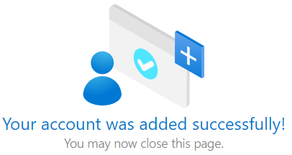Return to **Azure Data Studio**
5. From the **Side Bar** in **Azure Data Studio** Select: Your Azure Account 🡪 Azure for Students 🡪 SQL Server 🡪 **ist659*yournetid***, then click the connection button:  
   
6. You will be prompted for connection information:
   1. Server: **ist659*yournetid*.database.windows.net**
   2. Authentication Type: **SQL Login**
   3. User name: ***yournetid***
   4. Password: <Your password from Step 1.5.d.iii>
   5. Check: **remember password**
   6. Click: **Connect**
7. In the **Side Bar** under **SERVERS** you should now see the database as connected!  
   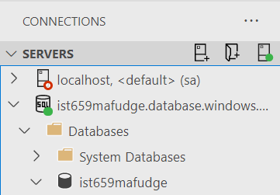

You can now write queries and SQL scripts against the database as you would your local db!

## Step 3: Create the Schema for Fudgemart business Applications

Next, Create the schema in your azure database. Download the schema and data here:  
<https://raw.githubusercontent.com/mafudge/learn-databases/master/schemas/fudgemart-v3/mssql/fudgemart_business_apps_sql_schema_data.sql>

And execute it against the **ist659*yournetid*** database on Azure to create your tables:

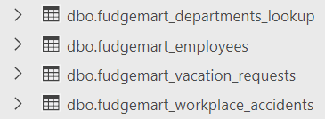

## Step 4: Building and Publishing the PowerApp

Rather than walking you through the building of the PowerApp, and turning this into a 100-page lab, I’ve created a video for you to follow along to instead:

## [Microsoft PowerApps Walkthrough](https://www.youtube.com/embed/5OFur75XBM8?feature=oembed)

<https://youtu.be/5OFur75XBM8>

## Step 5: On Your Own!

As Instructed in the video, complete the Rest of the PowerApp:

* Make a Form screen to approve a vacation request and a button on the View Vacation Requests Screen.
* Make a Gallery screen to view all approve requests.
* Tie the navigation together to make sure you can navigate the app correctly.

## Follow Shane Young on YouTube!

Shane is a Microsoft MVP and has posted over 150 videos (and counting) about PowerApps.

<https://www.youtube.com/channel/UC7_OGRP8BYvtGB8eZdPG6Ng>

# Questions

Answer these questions using the problem set submission template. You will need to provide a screen shot for each answer. Please follow the guidelines for submitting a screenshot.

1. Record a video of your working PowerApps completed from Steps 1 through 5 in the walk through. Make sure your video demonstrates all of the features (employees, vacation requests, view/add/edit a request) approve a request and approved requests. Post a link to your video so that I can review your PowerApps. Publish your video as a public link so I may access without credentials. You can post to YouTube, Vimeo, or video.syr.edu. All you need to include is a link.

**How do I record my screen?**

If you are not familiar with screen recording software:

* SU Offers Kaltura go to <https://video.syr.edu>, login with your NetID and password, click Add new Kaltura Capture and follow the instructions. You download Kaltura Capture to your computer.
* You can also try these in Chrome Browser tools: <https://www.screencastify.com/> or <https://screencast-o-matic.com/> These services both use chrome extensions.
* Or you can start on your pro journey now, and use what your prof uses: OBS <https://obsproject.com/> . If you feel that’s too much, try the more polished Streamlabs version <https://streamlabs.com/streamlabs-obs>.